- Use ChatGPT to generate a list of 15 keyword ideas for a new food delivery app targeting college students in Ahmedabad.<br><br><em><strong>Hint:</strong> Try prompts like 'Suggest SEO keywords for a food delivery app for college students in Ahmedabad.'</em>
Here are 15 SEO keyword ideas for a food delivery app targeting college students in Ahmedabad:
- food delivery for college students in Ahmedabad
- cheap food delivery in Ahmedabad
- affordable food near college in Ahmedabad
- food delivery near colleges in Ahmedabad
- student-friendly food delivery Ahmedabad
- budget food delivery Ahmedabad
- cheap meals for college students Ahmedabad
- best food delivery app in Ahmedabad
- late night food delivery Ahmedabad
- online food delivery near college
- student meal delivery Ahmedabad
- pocket-friendly food delivery Ahmedabad
- food delivery deals for students Ahmedabad
- fast food delivery near college Ahmedabad
- affordable meals near university Ahmedabad
- Write 2 different prompts for ChatGPT that would help you get long-tail keyword suggestions for a cricket livestreaming website. Compare the results and note which prompt gave you more relevant keywords.<br><br><em><strong>Hint:</strong> One prompt should be very specific, the other more general.</em>

Prompt 1 — Specific
“Act as an SEO keyword research expert. Generate 20 long-tail keywords for a cricket livestreaming website targeting Indian cricket fans. Focus on keywords with clear search intent around watching live cricket matches, IPL live streaming, international cricket, mobile streaming, and online cricket viewing. Avoid broad 1–2 word keywords and prioritize natural phrases that users may actually search on Google.”

List 1 — Specific Long-Tail Keywords
- watch IPL live streaming online in India
- watch India cricket live match on mobile
- IPL live streaming for Android mobile users
- watch India vs Australia live cricket online
- watch India vs England live match online
- live cricket streaming in HD on mobile
- watch IPL matches online without cable
- watch T20 World Cup live streaming in India
- international cricket live streaming on mobile
- watch India home cricket series live online
- IPL live match streaming website for Indians
- watch cricket live online with match commentary
- live cricket streaming for Jio users in India
- watch cricket matches live on smartphone
- India cricket live streaming with score updates
- watch international cricket matches online in HD
- live IPL match streaming on Android phone
- watch cricket live online while traveling
- live cricket match streaming for Indian fans
- watch India cricket matches live in HD

Prompt 2 — General
“Suggest 20 long-tail SEO keywords related to cricket livestreaming that people may search for on Google.”

List 2 — General Long-Tail Keywords
- how to watch cricket live online
- where to watch cricket live streaming
- best website to watch cricket live
- watch live cricket matches online
- cricket match live streaming online
- how to stream cricket matches online
- live cricket online viewing options
- websites for live cricket streaming
- watch cricket online from mobile
- live cricket streaming platforms
- online cricket match viewing
- watch cricket matches on smartphone
- cricket live streaming services online
- how to watch live cricket on phone
- online live cricket viewing guide
- watch cricket matches in HD online
- live cricket streaming for mobile users
- cricket streaming online for fans
- best way to watch live cricket online
- live cricket match viewing online
- List 1: More specific → better for targeted SEO pages and match/competition-specific searches.
- List 2: More general → useful for blog topics, guides, and informational content.

- Take your keyword list for a music streaming app and use any free online AI tool (like ChatGPT or Google's Gemini) to group the keywords into 3 topic clusters based on user intent (for example: 'free music', 'playlist creation', 'Bollywood songs').

Bollywood Songs
Toh related keywords ko cluster kar sakte hain:
Cluster 1 – Latest Songs
- latest Bollywood songs
- new Bollywood songs
- Bollywood songs 2026
- latest Hindi songs
Cluster 2 – Romantic Songs
- romantic Bollywood songs
- Bollywood love songs
- best Bollywood romantic songs
Cluster 3 – Party/Dance Songs
- Bollywood party songs
- Bollywood dance songs
- best Bollywood songs for dance
- Pick 5 keywords from your Zomato-style restaurant search keyword list and use a free online keyword difficulty checker (like Ahrefs, SEMrush, or Moz free tools) to assess their difficulty scores. List the scores and suggest which keyword is easiest to rank for.
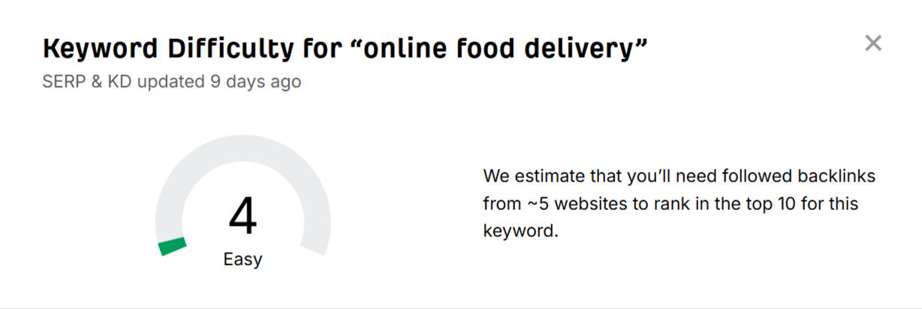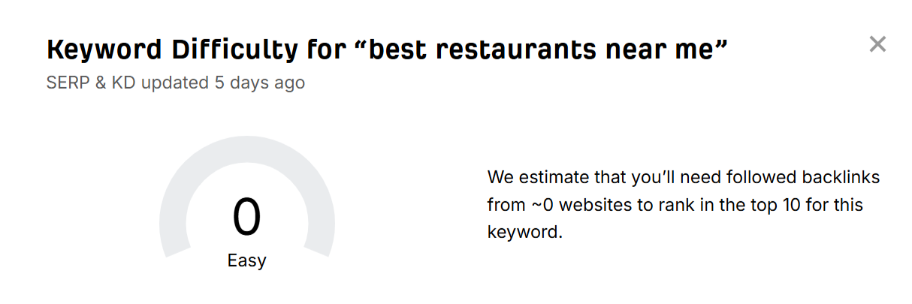
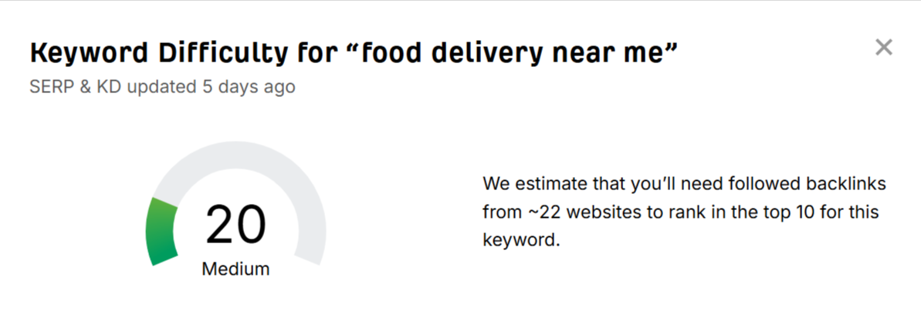
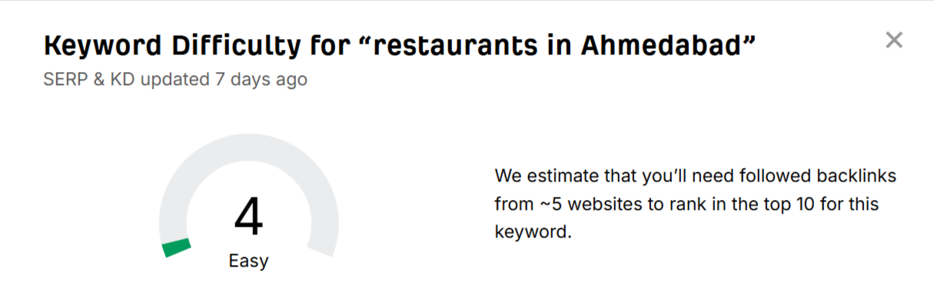
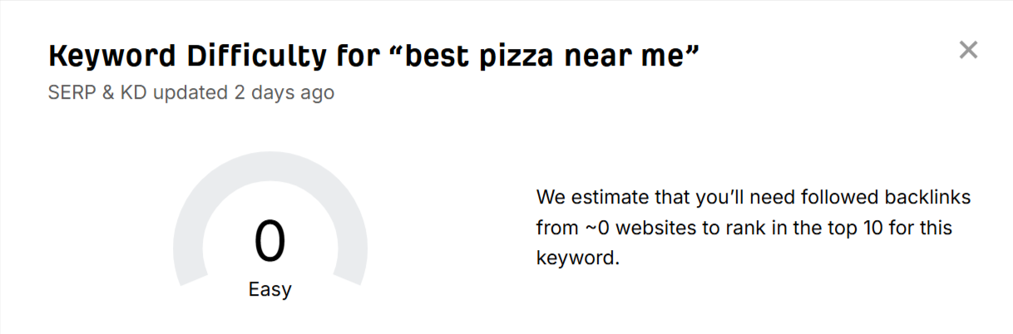
- Imagine you are building a topic cluster for a new IPL fan app. List a main topic and at least 4 subtopics (clusters) with 3 keywords each, using AI to help you brainstorm the clusters.<br><br><em><strong>Constraint:</strong> Do not repeat any keyword in more than one cluster.</em>

Cluster / Subtopic | 3 Keywords
IPL Live Scores & Matches | IPL live score, IPL match today, IPL live updates
IPL Teams & Players | IPL teams, IPL player stats, IPL team squad
IPL Schedule & Results | IPL schedule 2026, IPL match results, IPL upcoming matches
IPL News & Entertainment | IPL latest news, IPL match highlights, IPL cricket news

